 | 10.1.10 Editors - Compositor Editor - Header - Add Menu - Filter
Table of content
Detailed table of content 1
Add menu - Filter 6
Anti-Aliasing 6
Bilateral Blur 7
Blur 7
Bokeh Blur 9
Defocus 10
Denoise 12
Despeckle 12
Dilate/Erode 13
Directional Blur 14
Filter 15
Glare 16
Inpaint 17
Kuwahara 18
Pixelate 19
Sun Beams 19
Vector Blur 20

Detailed table of content

Detailed table of content
Detailed table of content 1
Add menu - Filter 6
Anti-Aliasing 6
Inputs 6
Image 6
Properties 6
Threshold 6
Contrast Limit 6
Corner Rounding 6
Outputs 6
Image 6
Bilateral Blur 7
Inputs 7
Image 7
Determinator 7
Properties 7
Iterations 7
Color Sigma 7
Space Sigma 7
Outputs 7
Image 7
Blur 7
Inputs 8
Image 8
Size 8
Properties 8
Filter Type 8
Flat 8
Tent 8
Quadratic 8
Cubic 8
Gaussian 8
Fast Gaussian 8
Catmull-Rom 8
Mitch 8
Variable Size 8
Bokeh 8
Gamma 9
Relative 9
Aspect Correction 9
X, Y 9
Extend Bounds 9
Outputs 9
Image 9
Bokeh Blur 9
Inputs 9
Image 9
Bokeh 9
Size 9
Bounding Box 10
Properties 10
Variable Size 10
Max blur 10
Extend Bounds 10
Outputs 10
Image 10
Defocus 10
Inputs 10
Image 10
Z 10
Properties 10
Bokeh Type 10
Angle 11
Gamma Correction 11
F-Stop 11
Max Blur 11
Threshold 11
Preview 11
Scene 11
Use Z-buffer 11
Z Scale 11
Outputs 12
Image 12
Denoise 12
Inputs 12
Image 12
Normal 12
Albedo 12
Properties 12
HDR 12
Outputs 12
Image 12
Despeckle 12
Inputs 13
Factor 13
Image 13
Properties 13
Threshold 13
Neighbor 13
Outputs 13
Image 13
Dilate/Erode 13
Inputs 13
Mask 13
Properties 13
Mode 13
Distance 13
Outputs 14
Mask 14
Directional Blur 14
Inputs 14
Image 14
Properties 14
Iterations 14
Center X, Y 14
Distance 14
Angle 14
Spin 14
Zoom 14
Outputs 14
Image 14
Filter 15
Inputs 15
Factor 15
Image 15
Properties 15
Filter Type 15
Soften 15
Sharpen 15
Laplace 15
Sobel 15
Prewitt 15
Kirsch 15
Shadow 15
Outputs 15
Image 15
Glare 16
Inputs 16
Image 16
Properties 16
Glare Type 16
Ghosts 16
Streaks 16
Fog Glow 16
Simple Star 16
Streaks 16
Angle Offset 16
Fade 16
Size 16
Fade 16
Rotate 45 17
Quality 17
Iterations 17
Color Modulation 17
Mix 17
Threshold 17
Outputs 17
Image 17
Inpaint 17
Inputs 17
Image 17
Properties 18
Distance 18
Outputs 18
Image 18
Kuwahara 18
Inputs 18
Image 18
Properties 18
Kuwahara Filter 18
Classic 18
Size 18
Anisotopic 18
Size 18
Smoothing 18
Outputs 18
Image 18
Pixelate 19
Inputs 19
Color 19
Outputs 19
Color 19
Sun Beams 19
Inputs 19
Image 19
Properties 19
Source width, height 19
Ray length 19
Outputs 19
Image 19
Vector Blur 20
Inputs 20
Image 20
Z 20
Speed 20
Properties 20
Samples 20
Blur 20
Speed 20
Min 20
Max 20
Outputs 20
Image 20

Add menu - Filter

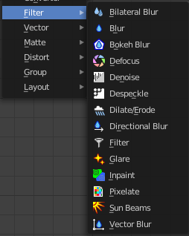

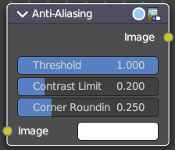
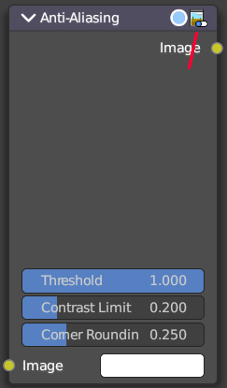
Anti-Aliasing
Adds antialiasing to edges in an image.

Inputs

Image
Standard image input.

Properties

Threshold
Threshold to detect edges.

Contrast Limit
How much to eliminate suspicious edges to avoid artifacts.

Corner Rounding
How much sharp corners will be rounded.

Outputs

Image
Standard image output.

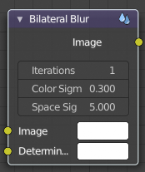
Bilateral Blur
The Bilateral Blur node performs a high-quality adaptive blur on the source image, allowing to blur images while retaining their sharp edges.
It can be used for various purposes like: smoothing noisy render passes to avoid longer computation times in example ray-traced ambient occlusion, blurry refraction's/reflections, soft shadows, or to make non-photo realistic compositing effects.

Inputs

Image
Standard image input. If only the image input is connected, the node blurs the image depending on the edges present in the source image.

Determinator
Which is non-obligatory and if the Determinator is connected, it serves as the source for defining edges/borders for the blur in the image. This has great advantage in case the source image is too noisy, but normals in combination with Z-buffer can still define exact borders/edges of objects.

Properties

Iterations
Defines how many times the filter should perform the operation on the image. It practically defines the radius of blur.

Color Sigma
Defines the threshold for which color differences in the image should be taken as edges.

Space Sigma
A fine-tuning variable for blur radius.

Outputs

Image
Standard image output.

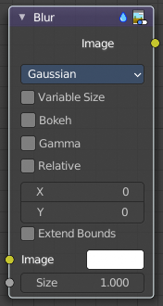
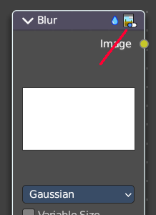
Blur
The Blur node provides several blur modes to blur an image. The icon top right allows you to collapse and show the image part of the node.

Inputs

Image
Standard image input.

Size
The optional Size input will be multiplied with the X and Y blur radius values. It accepts also a value image, to control the blur radius with a mask. The values should be mapped between (0 to 1) for an optimal effect.

Properties

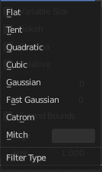
Filter Type
The difference between the types is in the way they handle sharp edges, smooth gradients and preserve the highs and the lows.

Flat
Simply blurs everything uniformly.

Tent
Preserves the high and the lows better by making a linear falloff.

Quadratic
Looks similar to Gaussian but can be a little faster but slightly worse looking.

Cubic
Preserve the highs, but give an almost out-of-focus blur while smoothing sharp edges.

Gaussian
Gives the best looking results but tends to be the slowest.

Fast Gaussian
An approximation of the Gaussian.

Catmull-Rom
Catmull-Rom keeps sharp contrast edges crisp.

Mitch
Preserve the highs, but give an almost out-of-focus blur while smoothing sharp edges.

Variable Size
Allows a variable blur radius, if the size input is an image.

Bokeh
The Bokeh button will force the Blur node to use a circular blur filter. This gives higher quality results, but is slower than using a normal filter.

Gamma
The Gamma button applies a gamma correction on the image before blurring it.

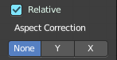
Relative
Percentage Value of the blur radius relative to the image size.

Aspect Correction
A subset of the Relative property. None, Y, X

X, Y
Values set the ellipsoid radius in numbers of pixels over which to spread the blur effect.

Extend Bounds
Allows the image, that is being blurred, to extend past its original dimension.

Outputs

Image
Standard image output.

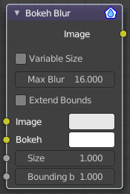
Bokeh Blur
The Bokeh Blur node generates a bokeh type blur similar to Defocus. Unlike defocus an in-focus region is defined in the Compositor.
Several performance optimizations are also available such as OpenCL support, calculation area restriction and masking.

Inputs

Image
Standard image input.

Bokeh
This is an input for the Bokeh Image node.

Size
Size controls the amount of blur. Size can either be a single value across the entire image or a variable value controlled by an input image. In order to use the latter, the Variable Size option must be selected. See the examples section below for more on how to use this.

Bounding Box
This can be used with a Box Mask matte node or with a Mask input node to restrict the area of the image the blur is applied to. This could be helpful, for example, when developing a node system by allowing only a small area of the image to be filtered thus saving composite time each time adjustments are made.

Properties

Variable Size
Allows a variable blur radius, if the Size input is an image.

Max blur
Max blur is intended to act as an optimization tool by limiting the number of pixels across which the blur is calculated.

Extend Bounds
Extend the bounds of the input image to fully fit the blurred image.

Outputs

Image
Image output.

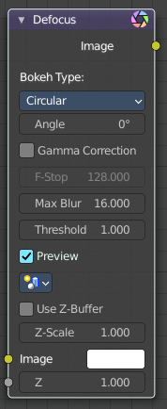
Defocus
It is typically used to emulate depth of field (DOF) using a post-processing method with a Z-buffer input. But also allows to blur images that are not based on Z depth too.

Inputs

Image
Standard image input.

Z
Z-buffer input, but could also be a (greyscale) image used as a mask, or a single value input.

Properties

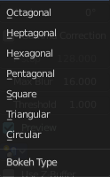
Bokeh Type
The number of iris blades of the virtual camera’s diaphragm.
Disk (to emulate a perfect circle) or Triangle (3 blades), Square (4 blades), Pentagon (5 blades), Hexagon (6 blades), Heptagon (7 blades) or Octagon (8 blades).

Angle
This button is deactivated, if the Bokeh Type is set to Disk. It can be used to add a rotation offset to the Bokeh shape. The value is the angle in degrees.

Gamma Correction
Applies a gamma correction on the image before and after blurring it.

F-Stop
This option controls the amount of focal blur in the same way as a real camera. It simulates the aperture f of a real lens’ iris, without modifying the luminosity of the picture. The default value 128 is assumed to be infinity: everything is in perfect focus. Half the value will double the amount of blur. This button is deactivated, if No Z-buffer is enabled.

Max Blur
This value limits the amount of blur by setting a maximum blur radius. Could be used to optimize the performance. The default value of 0 means no limit.

Threshold
Some artifacts, like edge bleed, may occur, if the blur difference between pixels is large. This value controls how large that blur difference considered to be safe.

Tip! Only change this value, if there is an occurring problem with an in-focus object.

Preview
If enabled a limited amount of (quasi-)random samples are used to render the preview. This way of sampling introduces additional noise, which will not show up in the final render.

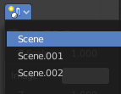
Scene
Select the linked scene. Scenes can be created in the properties editor in the Scene properties tab in the Scene panel.

Use Z-buffer
Should be activated for a non Z-buffer in the Z input. No Z-buffer will be enabled automatically whenever a node that is not image based is connected to the Z input.

Z Scale
Only active when No Z-buffer is enabled. When No Z-buffer is used, the input is used directly to control the blur radius (similar to F-Stop when using the Z-buffer). This parameter can be used to scale the range of the Z input.

Outputs

Image
Image output.

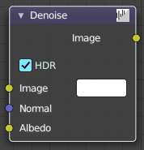
Denoise
The Denoise node is used to denoise renders from Cycles and other ray tracing renderers. This helps to significantly reduce render time by rendering with fewer samples.
It is uses Open Image Denoise, which transforms noisy images into clean images with machine learning.

Inputs

Image
Noise image input.

Normal
Optional normal render pass to better preserve detail. For Cycles, it is recommended to use the Denoising Normal render pass, which is available when enabling the Denoising Data passes.

Albedo
Optional Albedo render pass to better preserve detail. For Cycles, it is recommended to use the Denoising Albedo render pass, which is available when enabling the Denoising Data passes.

Properties

HDR
Preserve colors outside the 0 to 1 range.

Outputs

Image
Denoised image output.

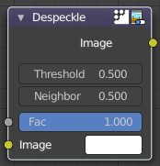
Despeckle
The Despeckle node is used to smooth areas of an image in which noise is noticeable, while leaving complex areas untouched.
This works by the standard deviation of each pixel and its neighbors is calculated to determine if the area is one of high complexity or low complexity. If the complexity is lower than the threshold then the area is smoothed using a simple mean filter.

Inputs

Factor
Controls the amount the filter effects the image.

Image
Standard image input.

Properties

Threshold
The threshold to control high/low complexity.

Neighbor
The threshold to control the number of pixels that must match.

Outputs

Image
Standard image output.

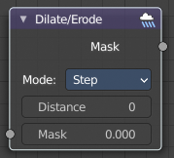
Dilate/Erode
The Dilate/Erode node provides a morphology (mathematical shape analysis) filter.

Inputs

Mask
Single color channel (or a black-and-white image) input.

Properties

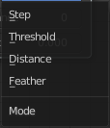
Mode
There are four different dilate / erode modes. Step, Threshold, Distance and Feather.

Distance
The Distance is the filter radius. A positive value of Distance dilates (expands) the influence of a pixel on its surrounding pixels. A negative value erodes (shrinks) its influence.

Outputs

Mask
The filtered mask output.

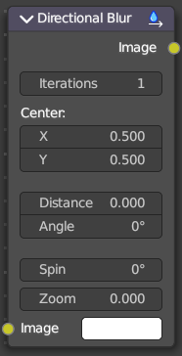
Directional Blur
Blurs an image in a specified direction and magnitude. Can be used to fake motion blur.

Inputs

Image
Standard image input.

Properties

Iterations
Controls how may times the image is duplicated to create the blur effect. Higher values give smoother results.

Center X, Y
Sets the position where the blur center is. This makes a difference if the angle, spin, and/or zoom are used.

Distance
How large the blur effect is.

Angle
Image is blurred at this angle from the center.

Spin
Rotates the image each iteration to create a spin effect, from the center point.

Zoom
Scales the image each iteration, creating the effect of a zoom.

Outputs

Image
Image output.

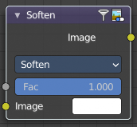
Filter
The Filter node implements various common image enhancement filters.

Inputs

Factor
Controls the amount of influence the node exerts on the output image.

Image
Standard image input.

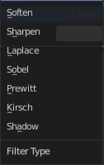
Properties

Filter Type
The available filter types. Soften, Laplace, Sobel, Prewitt and Kirsch all perform edge detection (in slightly different ways) based on vector calculus and set theory equations.

Soften
Slightly blurs the image.

Sharpen
Increases the contrast, especially at edges.

Laplace
Softens around edges.

Sobel
Creates a negative image that highlights edges.

Prewitt
Tries to do Sobel one better.

Kirsch
Giving a better blending than Sobel or Prewitt, when approaching an edge.

Shadow
Performs a relief, emboss effect, darkening outside edges.

Outputs

Image
Standard image output.

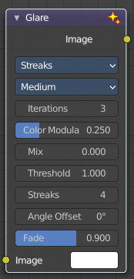
Glare
The Glare node is used to add lens flares, fog, glows around exposed parts of an image and much more.

Inputs

Image
Standard image input.

Properties
Note that some of the properties just appears with the corresponding glare type and the corresponding quality setting.

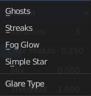
Glare Type

Ghosts
Creates a haze over the image.

Streaks
Creates bright streaks used to simulate lens flares.

Fog Glow
Looks similar to Ghost. However, it is much smaller in size and gives more of an atmospheric haze or “glow” around the image.

Simple Star
Works similar to Streaks but gives a simpler shape looking like a star.

Streaks
Total number of streaks.

Angle Offset
The rotation offset factor of the streaks.

Fade
Fade out factor for the streaks.

Size
Scale of the glow relative to the size of the original bright pixels.

Fade
Fade out factor for the streaks.

Rotate 45
Rotate the streaks by 45°.

Quality
If not set to something other the High, then the glare effect will only be applied to a low resolution copy of the image. This can be helpful to save render times while only doing preview renders.

Iterations
The number of times to run through the filter algorithm. Higher values will give more accurate results but will take longer to compute. Note that, this is not available for Fog Glow as it does not use an iterative-based algorithm.

Color Modulation
Used for Streaks and Ghosts to create a special dispersion effect.
Johannes Itten describes this effect, Color Modulation, as subtle variations in tones and chroma.

Mix
Value to control how much of the effect is added on to the image. A value of -1 would give just the original image, 0 gives a 50/50 mix, and 1 gives just the effect.

Threshold
Pixels brighter than this value will be affected by the glare filter.

Outputs

Image
Standard image output.

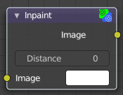
Inpaint
The Inpaint node is used to extend borders of an image into transparent or masked regions. This can be useful to solve problems like “wire removal” and holes created during chroma keying.

Inputs

Image
Standard image input.

Properties

Distance
The number of times to extend the image.

Outputs

Image
Standard image output.

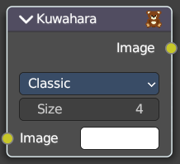
Kuwahara
Kuwahara is a filter that converts a realistic image into a stylized image.

Inputs

Image
Standard image input.

Properties

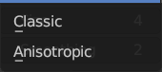
Kuwahara Filter
There are two Kuwahara variations available. Classic and Anisotropic.

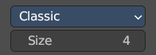
Classic

Size
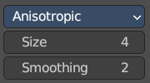
The size of the Kuwahara filter.

Anisotopic

Size
The size of the Kuwahara filter.

Smoothing
Smoothing degree before applying filter.

Outputs

Image
Standard image output.

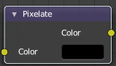
Pixelate
Add this node in front of a Scale node to get a pixelated (non-smoothed) image from the resultant upscaled image.

Inputs

Color
Standard image input.

Outputs

Color
Image output.

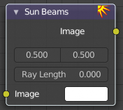
Sun Beams
The Sun Beams node provides a computationally cheap way of creating the name giving effect based on the image brightness alone.
Sun Beams is a 2D effect for simulating the effect of bright light getting scattered in a medium (Crepuscular Rays). This phenomenon can be created by renderers, but full volumetric lighting is a rather arduous approach and takes a lot of render time.

Inputs

Image
Standard image input.

Properties

Source width, height
Source point of the rays as a factor of the image dimensions.

Ray length
Length of the rays as a factor of the image size.

Outputs

Image
Image output.

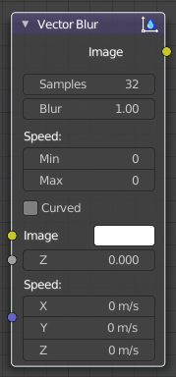
Vector Blur
The Vector Blur node is a fast method for simulating Motion blur in compositing. It uses the vector speed render pass to blur the image pixels in 2D.

Inputs

Image
Image input, to be linked to the “Combined” render pass.

Z
Z depth, to be linked to the “Depth” render pass.

Speed
Input for the “Vector” render pass. See Cycles render passes.

Properties

Samples
Quality factor.

Blur
Scaling factor for the motion vector (actually the “shutter speed” in frames).

Speed
The vector blur could produce artifacts like streaks, lines and other. To tackle these problems, the filter applies clamping, which can be used to limit which pixels get blurred. The speed is set in pixel units.

Min
The minimum threshold for moving pixels can separate the hardly moving pixels from the moving ones. Especially when the camera itself moves, the vector mask can become the entire image.

Max
The maximum threshold. The majority of artifacts are caused by pixels moving too fast.

Outputs

Image
Motion blurred image output.

